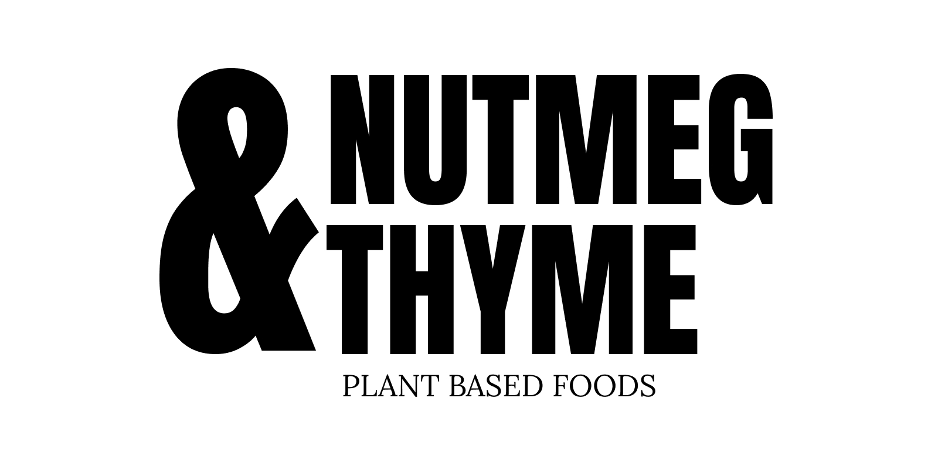

**100% Gluten, Dairy, Wheat, Egg Free Kitchen**

**We revolve our menus around seasonal and local produce, all our food is prepared fresh in the cafe by Grace and Emily.**

**ARTISAN SANDWICHES**

**made fresh with our focaccia and local organic leaves**

**£8.50**

**Fig Chutney, Pesto & Camembert (cashew)**

**Garlic roasted Artichokes, Whipped Butterbean, Leek & Tahini (sesame)**

**Roasted Oyster Mushroom & Smashed Pea pesto**

**HOT BOWLS £8**

**served with our focaccia or a side salad selection £11**

**(our Hot bowls change regularly, some favourites include):**

* **Aubergine Sicilian Style Stew**
* **Squash & Coconut Dal**
* **Celeriac Hazelnut Butter Soup**
* **Thai Spiced Root & Coconut Soup**
* **Oyster Mushroom Ragu**
* **Harissa Caraway Aubergine Stew**

**BRUNCH DISHES £12**

**Root Veg Rostis**

**or**

**Thai Spiced Sweetcorn Fritters**

**with Pea Basil Guacamole and a selection of seasonal salads**

**SEASONAL SALAD SELECTION**

**£7 side**

**£10 main**

**(our selection changes regularly, including)**

**Green Bean Hazelnut Orange**

**Celeriac, Pecan, Parsley**

**Carrots, Black Rice, Basil**

**Tahini Slaw**

**Roasted Chipotle Pineapple Salsa**

**Black Chickpeas, Roasted Roots**

**Turmeric Cauliflower, Almond Romesco**

**OUR BAKES & TREATS SELECTION**

**includes…**

**Gingerbread Passionfruit Cake (maize)**

**Chocolate Fudge Cake (maize)**

**Tahini Almond Cookies (sesame, nuts)**

**Rosemary Hazelnut millionaires Shortbread (nuts, gf oats)**

**Squash / Tomato / Celeriac Tarte Tatin (soy, maize)**

**Focaccias - Squash & Sage, Olives & Rosemary (yeast, maize)**

**Millet Bread (yeast)**

**Pecan Miso Mushroom Rolls (maize, nuts, soy)**

**SMOOTHIES**

**cacao, espresso, hazelnut butter, banana**

**greens, mango, ginger, coconut**

**pear, cardamom, tahini, oat**

**berry, mango & basil**